**Name: Eze Daniel Ndubisi**

**Data source:** [UK House Price Index summary: December 2022 - GOV.UK (www.gov.uk)](https://www.gov.uk/government/statistics/uk-house-price-index-for-december-2022/uk-house-price-index-summary-december-2022" \l "sales-volumes)

**VISUALIZATION 1:** **line plot of Annual price change of United Kingdom countries: England, Scotland, Wales, Northern Ireland**

# 

Line plot is good to represent trends and pattern in for the changes in prices for UK countries over the continuous change in data over five years period

From the line plot, it can be inferred that the average house price index measures the price of house relative to a based period. So, changes in the average house price indicate the relative change in the house prices compared to the base period

The graph suggests that the price changes have varied across the United Kingdom during the period under consideration.

There is an overall upward trend in price changes for the United Kingdom as a whole, with the highest occurring in July, 2022. Scotland experienced drop in July, 2020 while Wales has higher price change as compared to other countries in July, 2022.

**VISUALIZATION 2: Bar plot of Sales volumes for the UK over the past 5 years**

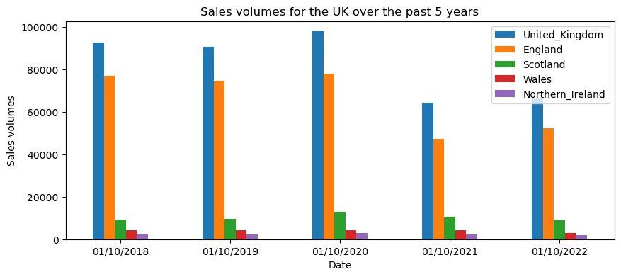

My choice of representing the annual sales volume for United Kingdom and countries on bar chat is for easy of comparison. Also suitable for my data set as it has a discrete data not connected by a continuous line.

It can easily be visualized, countries that has the highest sales volume for as particular period. From the graph, there is decline in sales volumes across the countries and United Kingdom as a whole from 2018 to 2022. While England has the highest sales volume and Northern Ireland the least.

**VISUALIZATION 3: Pie plot of Average Monthly Price by Property Type**

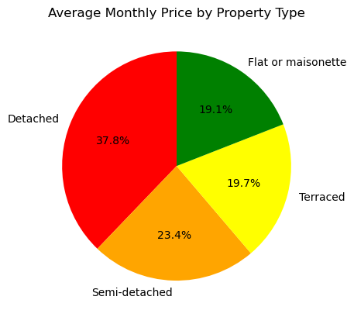

For easy of visualizing how each price of property types constitutes to the Average monthly price for whole property types in 2022, I resort to represent the data on pie-chart.

From the graph, it can easily be seen that the Detached make up of 37.80% of the total Average monthly price of all the property types. Likewise, semi-detached: 23.40%, Terraced: 19.70% and Flat or Maisonette: 19.10%